Problem Statement: Create a windows VM machine in AWS and connect with RDP open CMD in windows share the about system info

Steps to create a windows Instance:

Click on Launch Instance

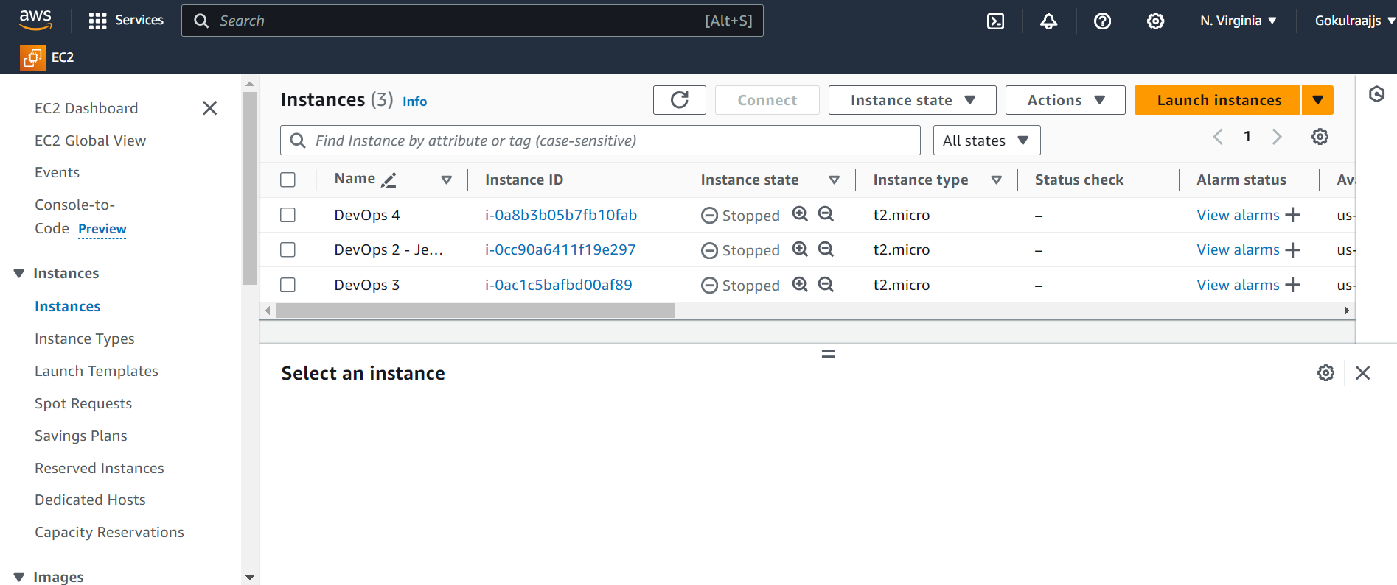

Provide a name to the instance and select the AMI as Windows

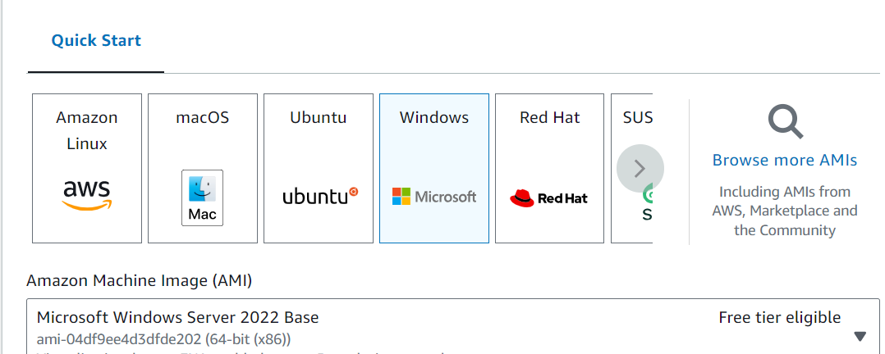

Select the Keypair and launch the instance

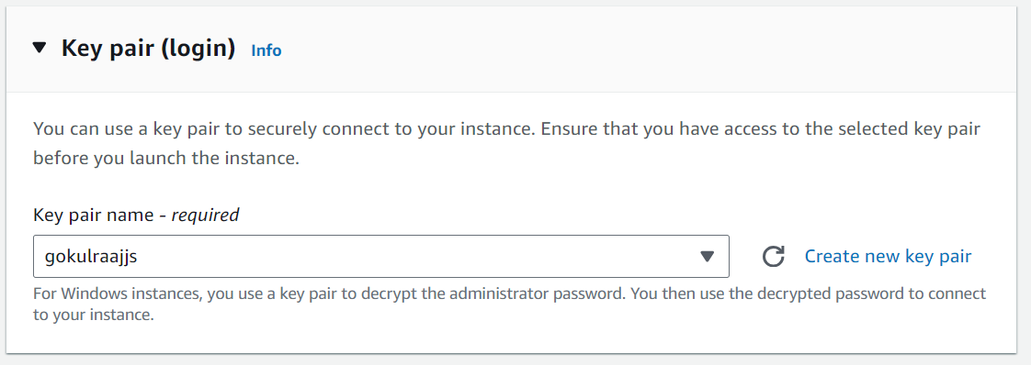

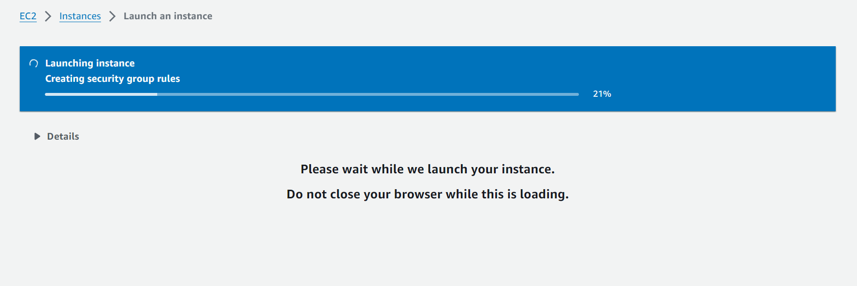

Now connect to the instance via the RDP client, by decrypting the password

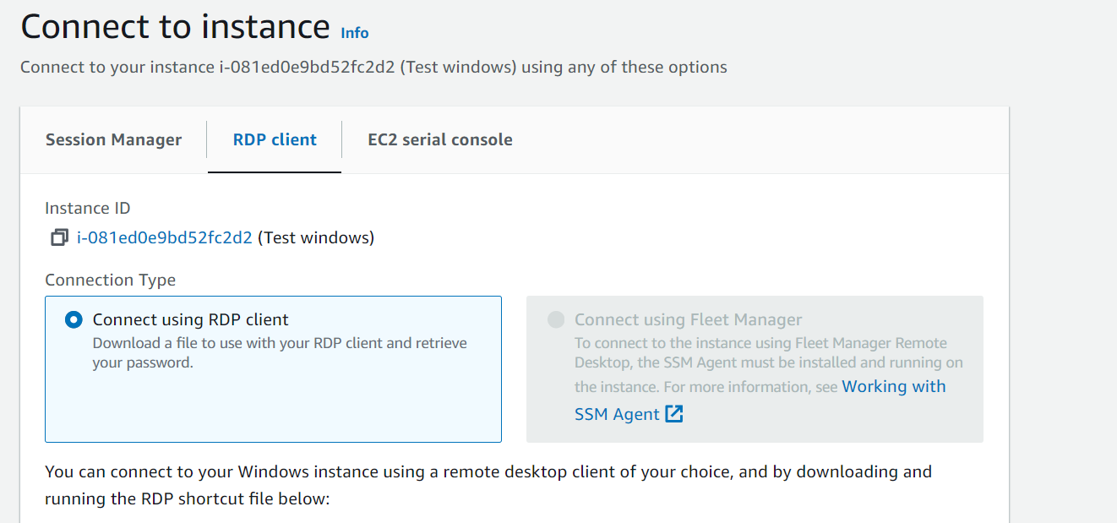

After connecting the system information of the Windows instance is,

